Lab-3

Update & Delete Records

DELETE

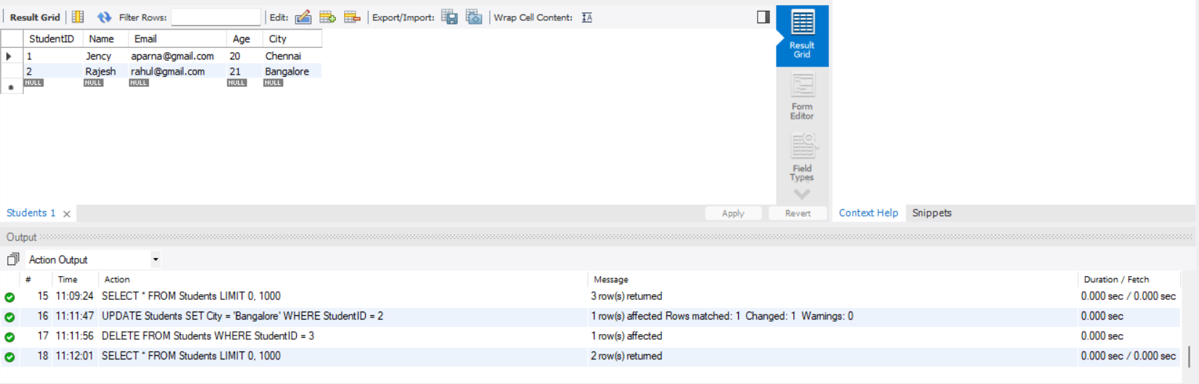

UPDATE

